**Cambridge IETLS 6 Test 1 Writing**

Task 1

The graph illustrates three categories of water consumped around the world, which are agriculture, industrial and domestic use, from 1900 to 2000. Units are measured in cubic kilometres. The table demonstrates the usage of water in Brazil and Congo in 2000.

Overall, the amount of water used in agriculture was constantly the largest comparing with that of domestic use as the smallest. Water being used for each person in Brazil was significantly higher than one in Congo in 2000.

To begin with, there were about 500 cubic kilometeres of water being used in farming in 1900 and the data of it had increased steadily before 1940s. After that it increased dramatically(in the following years) and reached to 3000 in 2000. On the contrary, the usage between industry and household were not notably different before 1940; both of them were lower than 100 cubic kilometres. Whereas, water for industry had increased steeply since then and it reached 1000 in the final year.

The table shows detailed data of Brazil and Congo with the data of their residents, sqaure metres of irrigation and usage for each individual.

***Errors in my report:***

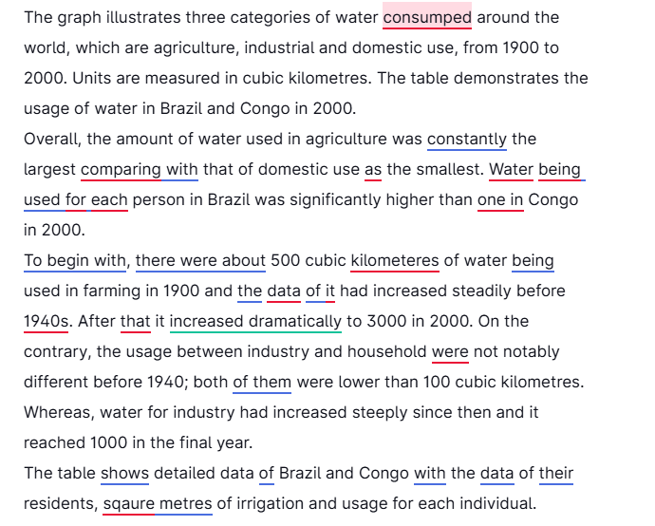

***After correction:***

The graph illustrates three categories of water consumed around the world, which are agriculture, industrial and domestic use, from 1900 to 2000. Units are measured in cubic kilometres. The table demonstrates the usage of water in Brazil and Congo in 2000.

Overall, the amount of water used in agriculture was constantly the largest compared that of domestic use was the smallest. The amount of water used for each person in Brazil was significantly higher than that in Congo in 2000.

To begin with, there were about 500 cubic kilometres of water being used in farming in 1900 and the amount of it had increased steadily before the 1940s. After that, it increased dramatically to 3000 in 2000. On the contrary, the usage between industry and household was not notably different before 1940; both of them were lower than 100 cubic kilometres. Whereas, water for industry had increased steeply since then and it reached 1000 in the final year.

The table shows detailed data of Brazil and Congo including the data of their residents, square metres of irrigation and usage for each individual.

***Analyses:***

In the table, the consumption of water for each person in Brazil was radiculously much higher than that of D.R.C, which indicated that the amount of water used in agriculture was enormous and the data reflected tha averge usage of water per person. Apparently, a single person in Brazil couldn’t have consume such a huge amout of water.

***Improved by Grammarly***

The graph illustrates the consumption of water worldwide in three categories: agriculture, industrial use, and domestic use, from 1900 to 2000. The units are measured in cubic kilometers. Additionally, the table provides data on water usage in Brazil and Congo in the year 2000.

Overall, agricultural water consumption was consistently the highest, while domestic use was the lowest. Furthermore, the amount of water used per person in Brazil was significantly greater than that in Congo in 2000.

To begin with, approximately 500 cubic kilometers of water were used for agricultural purposes in 1900, and this amount steadily increased until the 1940s. After that, agricultural water usage surged dramatically, reaching 3,000 cubic kilometers by 2000. In contrast, water consumption for industrial and household purposes was similar prior to 1940, with both categories being below 100 cubic kilometers. However, water usage for industry increased sharply after that, reaching 1,000 cubic kilometers in the final year.

The table presents detailed information about Brazil and Congo, including data on their populations, the area of land under irrigation, and water usage per individual.

**Task 2**

Nowadays, various advertisements are overwhelming everywhere. Some buyers are misled to purchase what they even don’t(1) need. In my opinion, although the value of many procuts are exagerated(2), we can know more about something what(3) we want to buy when they are advertised.

In fact, customers are easily to be convinced by unrealistic slogans and spend money on something which(4) is not essential for their daily life. To ilustrate, elderly people buy an radiculously(5) expensive machine which they mighty(6) use only once a year for just minor diseases. It is the seller who should be blamed. Many companies increase theirs (7)sales by spending considerable amount of(8) money on advertising but (9) it is counterproductive when they overstate the effct(10) of the goods. Buyers always has little information about the truth so it is absolutely necessary for government(11) to regulate the market. (NOT logical)

On the other hand, we, as purchasers, are able to know more about the good we genuinly need by watching advertisements on TV or other media. Some of them are carefully made to introduce major feature(12) of a selling product. It is helpful to make sensible decision(13) by watching them. For instance, car manufacturers show off the capability of an off-road vehicles on a muddy road, which definitely help potential buyers to have a comprehensive understanding of it.

In conclusion, some advertisements don’t help us make sound judgement(14) but mislead us. There shoud be law(15) uphold by watch dogs to punish thees(16) liars. Whereas, some of them do help customers know more about the goods before hand(17). When we don’t have any manual(18), it is an effective way help us find what we need.

**Analysis:**

1. After review my essay, I think I didn’t response the question exactly. The question is about whether the high sales of goods are influenced by advertisements or not. It asked that if consumers are really need what they have bought, or they’re misled by exaggerating advertisements. The topic is about sales, but not advertisements. Wheareas, my essay is focus on the effects of advertisements.

**Errors:**

1. “even don’t need” : don’t even need
2. “procuts are exagerated”:

There are three errors: the spelling of “procuts”, “are” and the spelling of “exagerated”.

products, is, exaggerated.

1. “something what” : something that we want to buy
2. “something which”: something that is essential
3. “radiculously”: spelling error. ridiculously
4. “mighty”: might
5. “theirs”: their
6. “spending considerable amount of money”:

**a** considerable amount of money

1. “on advertising but it is counterproductive”:

There should be a comma “,” before “but”.

1. “effct”: effect
2. “government”: the government
3. “major feature”: **a** major feature.
4. “decision”: It should be plural.
5. “judgement”: It also should be plural.
6. “law”: a law or laws
7. “thees”: a spelling error
8. “before hand”: beforehand.
9. “any manual”: any manuals or a manual
10. “an effective way help”: an effective way to help

**Other errors**

*Many companies increase theirs sales by spending considerable amount of money on advertising but it is counterproductive when they overstate the effct of the goods. Buyers always has little information about the truth so it is absolutely necessary for government to regulate the market. (NOT logical)*

This excerpt is not logical. The adjective “counterproductive” is inappropriate because sellers have achieve theirs goals by persuade customers to buy their goods. Therefore it works, but not “counterproductive”. I should have used “effective” instead.

**Improved by me:**

Many companies invest a considerable amount of money on advertising to increase the sales of their products by overstating the effects. Customers tend to believe them since they have little information about the truth. It is absolutely necessary for the government to uphold the law to protech customers.

Note: “regulate the market” is Chinglish and is not an appropriate collocation.

**Improved by Grammarly**

Nowadays, various advertisements are overwhelming everywhere. Some buyers are misled to purchase what they even don’t need. In my opinion, although the value of many products is exaggerated, we can know more about something we want to buy when they are advertised.

In fact, customers are easily convinced by unrealistic slogans and spend money on something that is not essential for their daily life. To illustrate, elderly people buy a ridiculously expensive machine which they might use only once a year for just minor diseases. It is the seller who should be blamed. Many companies increase their sales by spending a considerable amount of money on advertising, but it is counterproductive when they overstate the effect of the goods. Buyers always have little information about the truth, so it is absolutely necessary for the government to regulate the market.

On the other hand, we, as purchasers, are able to know more about the goods we genuinely need by watching advertisements on TV or other media. Some of them are carefully made to introduce the major features of a selling product. It is helpful to make sensible decisions by watching them. For instance, car manufacturers show off the capability of off-road vehicles on a muddy road, which definitely helps potential buyers to have a comprehensive understanding of it.

In conclusion, some advertisements don’t help us make sound judgments but mislead us. There should be laws upheld by watchdogs to punish these liars. Whereas, some of them do help customers know more about the goods beforehand. When we don’t have any manual, it is an effective way to help us find what we need.

*I didn’t response the question properly so I rewrite my essay.*

Nowadays, advertisements are overwhelming on TV, on the Internet and every corner on the streets. Some people say that it is advertising that boost the sales of goods while others argue that customers are able to make sensible decisions when they are purchasing products. In my opinion, advertisements are not the key for the sales.

To begin with, it is plausible that a particular brand of commodity which has the high sales due to the advertising campaign. For instance, Coca Cola is argubly a successful company which make the best use of advertisements; we can see its name on almost every Olympic Games, which is the largest sports event around the world. In addition, consumers tend to buy something that they have seen on TV or billboards. Presumably, making advertisements increases the sales to some degree. It is not enough to only have prodominent advertising.

Whereas, many believe that it is the good quality that is the key factor of the sales and advertisements are not decisive. If your car broke down very often, would you buy the same brand even if there are enormous numbers of ads surrounding you? Buyers, especially adults, usually make sensible decisions when they are purchsing something since they can know every aspect of the good in the age of IT. When we know the truth, it is implausible for us to believe what celebrities say in advertisements and we will not buy something simultaneously.

In conclusion, although advertising contributes to the sales of the goods, there are other more important factors such as quality, services and so forth.